# Exp1 Elementary Programming

**1 Experiment purpose**

Through this training, to master and be familiar with the programming environment of Java language. Run a Java program; the students master the Java language data types, operators and expressions and other basic content. Understand the precedence of operators.

**2 Development Environment**

1. Notepad++
2. JDK 8+

**3 Content and Steps**

**Problem 1:** Write the first java program

**Steps:**

(1) Define a main class and do some simple thing.

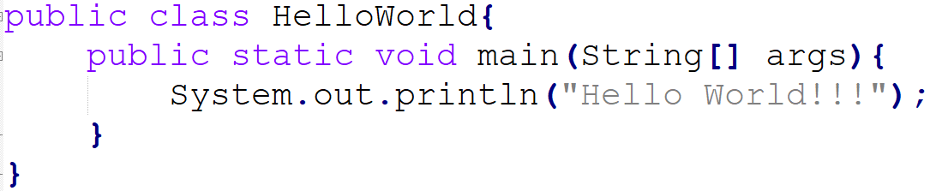

(2) Compile and run the program.







**Problem 2:** Solving linear equations

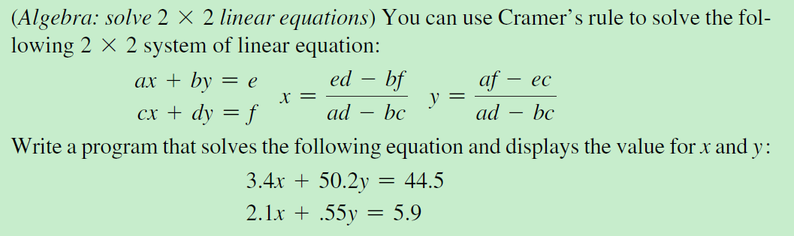

The expected result:

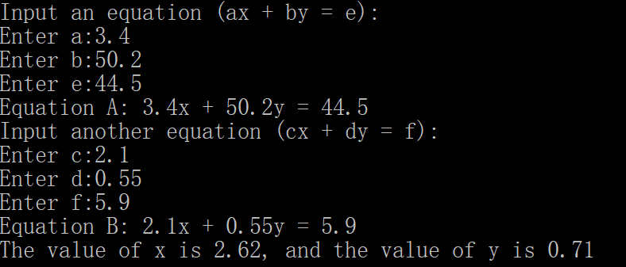

**Steps:**

(1) Define a main class and import the class *Scanner*.

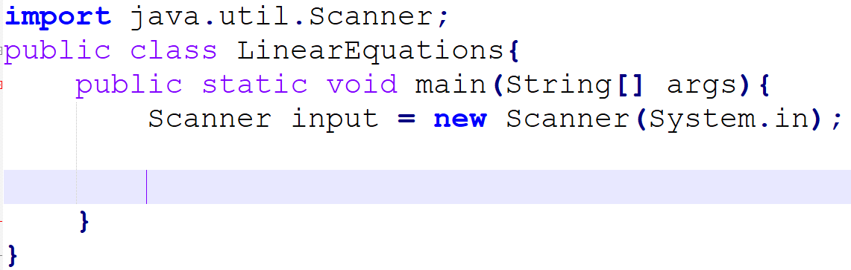

(2) Input two equations.

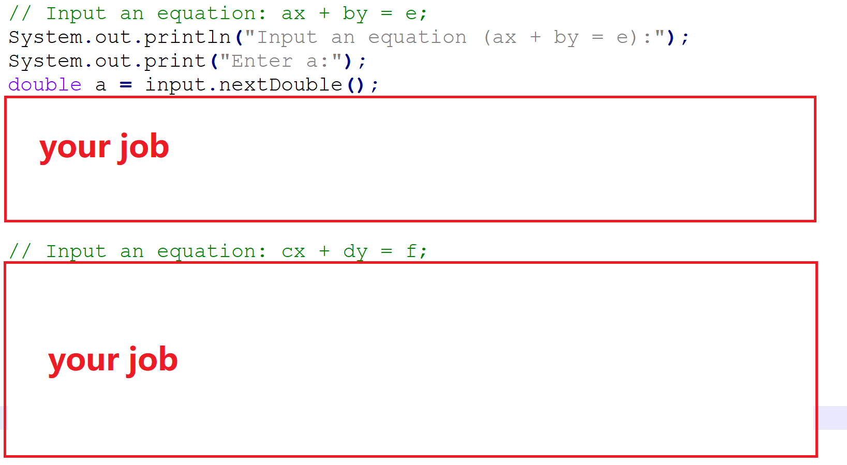

(3) Solve the linear equations and print the resluts.

